WindZ.co - Case Study
House facing army camp – The Rain Forest Condo。五鬼刹,五虎下山局
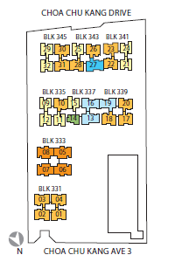
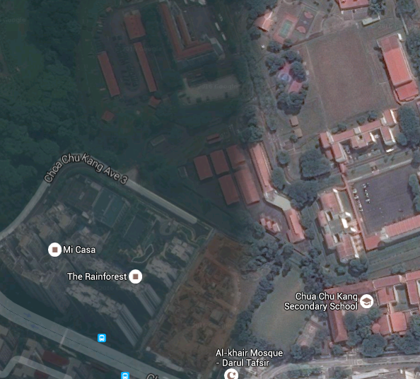
50% of the resident(left hand side ) is facing a very deadly sha –五鬼刹 from the camp directly. Building defect / workman ship at blk 331, 333, 335 & 345 will be endless.
Resident at 331 & 333 will easily get sick started from Feb 2016.
岁破
五黄
5 yellow
60% of the resident units are facing directly to the army camp

